No flow in $$θ$$ dir --> no eqs. In $$θ$$ dir. Since $$\frac{d}{dθ}=0$$

z-dir.

$$δ\left[\frac{dv_{2}}{dt}+vr \frac{dv_{2}}{dr}+\frac{vθ}{r} \frac{dv_{2}}{dθ}+v_{2} \frac{dv_{2}}{d2}\right]=\frac{dp}{d2}+δg_{2}+μ\left[\frac{1}{r} \frac{d}{dr}\left(r \frac{dv_{2}}{dr}\right)+\frac{1}{r^{2}} \frac{d^{2}v_{2}}{dθ^{2}}+\frac{d^{2}v_{2}}{d2^{2}}\right]$$

$$\frac{dp}{d2}= \frac{μ}{r} \frac{d}{dr} \left(r \frac{dv_{2}}{dr}\right)$$

Integrate w.r.t r twice:

$$v_{2}= \frac{dp}{d2 } \frac{r^{2}}{4μ}+c_{1}\ln\left(r\right)+c_{2}$$

To avoid any singularity at $$r=0$$ $$→$$ $$v_{2}$$ = finite value

$$\frac{dv_{2}}{dr}\left|=0\right|$$ $$→$$ denominator (dr) is the 2nd B.C.

|centerline of pipe

1st B.C. no slip at $$r=R$$ $$→$$ R = pipe radius

Using the 2 B.C. :

$$v_{2}={\left(−\frac{dp}{d2}\right)}_{ } \frac{1}{4μ}\left(R^{2}−r^{2}\right)$$

Eq. Of a paraboloid

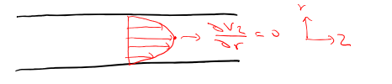

Note: Knowing the profile allows one to find:

1. Flow rate $$\left(Q\right)$$, ie. $$Q = δ v_{2}dA,$$ where $$dA=2πrdr$$
2. Shean at the wall (Twall) : Twall = $$μ \left(\frac{dv_{2}}{dr}\right)=\frac{R}{2} \frac{ΔP}{L}$$

L = length of pipeline segment

Our goals for today (Lect 8):

1. Solving a sample problem using differential forms of conservation equations
2. Irrotational flow and velocity

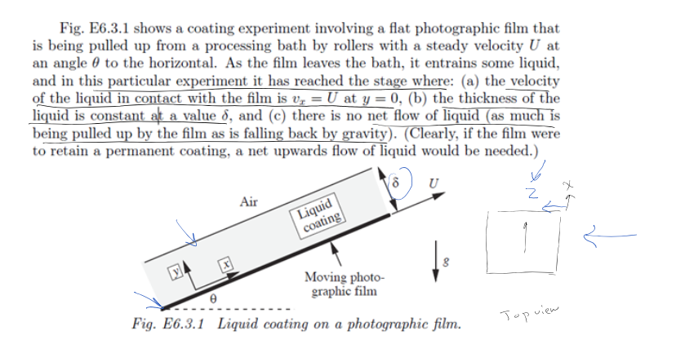

Note: Since there is no temp change (energy or work in/out), then we don’t concern ourselves with energy e.q (also because we’re not concerned with losses) ($$θ$$ term in energy e.q)

Assumptions:

* Newtonian fluid, steady flow
* No variation of Vel. In 2dir --> 2D flow
* No rotation --> no worries for conservation angular momentum --> continuity inear momentum

$$\frac{du}{dx}+\frac{dv}{dy}=0$$

$$δ\left(\frac{du}{dt}+u \frac{du}{dx}+v \frac{du}{dy}\right)=−\frac{dp}{dx}+μ\left(\frac{d^{2}u}{dx^{2}}+\frac{d^{2}u}{dy^{2}}\right)+δg_{x}$$

$$δ\left(\frac{dv}{dt}+u \frac{dv}{dx}+v \frac{dv}{dy}\right)=−\frac{dp}{dy}+μ\left(\frac{d^{2}v}{dx^{2}}+\frac{d^{2}v}{dy^{2}}\right)+δg_{y}$$

Note: looking from the top and side views of the system--> u >> v or w, so we can neglect v and w or v=w=0

Momentum:

$$\frac{dp}{dx}−δgsinθ=μ \frac{d^{2}u}{dy^{2}}$$

$$δgsinθ = g_{x}$$

$$\frac{dp}{dy}=δgsinθ$$

$$δgsinθ = g_{y}$$

Continuity:

$$\frac{du}{dx}=0$$

Note, v=0

B.C. to solve

1. y=0 u=U

2. At free surface shear force $$\left(T_{xy}\right)$$ is zero mechanical balance

$$T_{xy}=μ\left(\frac{dv}{dx}+\frac{du}{dy}\right)=μ \frac{du}{dy}=0 → \frac{du}{dy}=0$$ at interface y=5

3. Since we have a flat interface with air at y=5 --> p=0, gauge at m.

Solve above PDF with the 3 B.C.

Ans. $$u=U−\frac{δgsinθ}{μ}y\left(δ−\frac{y}{2}\right)$$

$$δ=\sqrt{\frac{3Uμ}{δgsinθ}}$$

Note: N.S eqs are complicated, so to find analytical solutions, either if the phys of problem allows, simplification, e.g probably above, or use of math. Tech should be done to find solution, otherwise CDF is needed.

Irroration Flow and Vorticity

These concepts are math. Tech to help with finding analytical solution to PDE of N.S.

See videos

If a fluid element does not have an angular vel. Around its centre, this flow is called irrotational

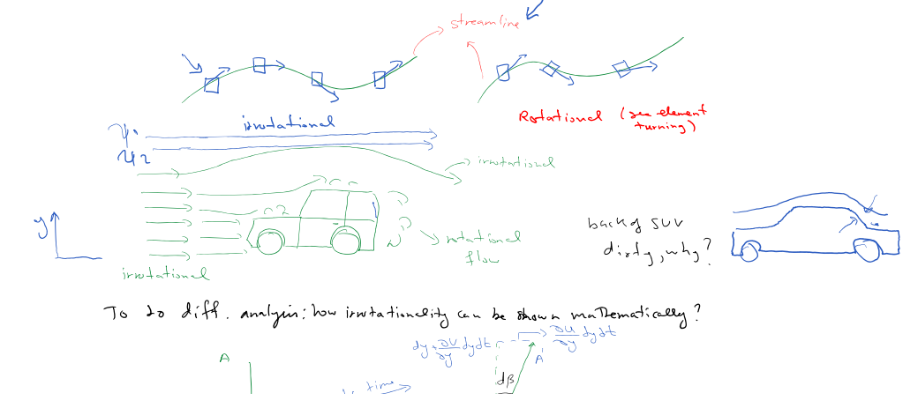

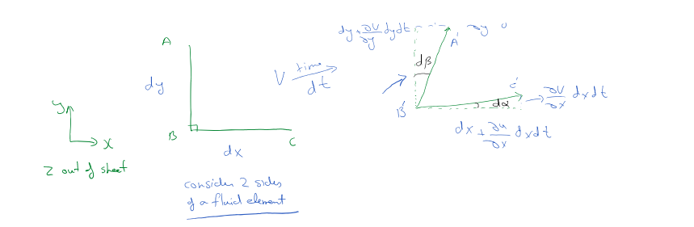

Avg rotational of element around 2 axis $$\left(w_{2}\right)$$:

$$w_{2}=\frac{1}{2}\left(\frac{dx}{dt}−\frac{dR}{dt}\right)$$

By trigonometry, it can be shown:

$$\frac{dx}{dt}=\frac{dv}{dx}$$ and $$\frac{dD}{dt}=\frac{du}{dy}$$

Then, $$w_{2}=\frac{1}{2}\left(\frac{dv}{dx}−\frac{du}{dy}\right)$$

For rotation around x and y axis, it can be shown:

$$w_{x}=\frac{1}{2}\left(\frac{dw}{dy}−\frac{dv}{d2}\right)$$ and $$w_{y}=\frac{1}{2}\left(\frac{du}{d2}−\frac{dw}{dx}\right)$$

$$w=iw_{x}+jw_{y}+kw_{2}=\frac{1}{2}∇xv=\frac{1}{2}\left|\frac{d}{dx} \frac{d}{dy} \frac{d}{dz}\right|$$

Voracity = $$2w = ∇xv$$

If $$∇xv = 0$$ or zero voracity, the flow is irrational

What is this good for?

We have a math tool to solve for flow field (get v, u, p...)

\*This tool is best suited for 2D flows where there is no work or heat involved since there is no work or heat, I can be concerned with conservation of man and momentum:

For an incorporable flow of, where flow is steady:

$$\frac{du}{dx}+\frac{dv}{dy}=0$$ (I)

$$\frac{}{dx}+\frac{dv}{dy}=0$$ (I)

$$δg−∇p+μ∇^{2}v=0$$ (ii)

Consider a function $$ψ$$ exists (note $$ψ \left(x,y\right)$$) that one can write:

$$\frac{d}{dx}\left(\frac{dψ}{dy}\right)+\frac{d}{dy}\left(−\frac{dψ}{dx}\right)=0$$ (iii)

^u ^v kind of like substitution of variable T in match

Then by inspection of eg (iii) vis.a.vis eg(I):

$$u=\frac{dψ}{dy}$$ and $$v=\frac{dv}{dx}$$ (19)

If one takes the curl of momentum eg (I.e $$∇x$$ [eq (ii)]), and use $$ψ$$ definition from Eq 19, then:

$$\frac{dψ}{dy} \frac{d}{dx} \left(∇^{2}ψ\right)−\frac{dψ}{dx} \frac{d}{dx}\left(∇^{2}ψ\right)=\frac{μ}{p}∇^{2}\left(∇^{2}ψ\right)$$ (iv)

Eq (iv) is a 4th order PDE that needs 4 B.C.

Aside the driving eq (iv) :

$$∇x\left(∇F\right)=0$$

$$\frac{d^{2}ψ}{dx^{2}}+\frac{d^{2}ψ}{dy^{2}}=∇^{2}ψ$$

Special Case:

Irrotational flow $$→ ∇xv=0$$---------------> $$−κ∇^{2}ψ=0$$

in 2D

Eq (iv) row simplifies to a 2nd order PDE, which needs 2 B.C. only

B.C: $$ψ =$$ const at body

$$ψ =U_{∞}Y +$$ const (at far field--> very much away from the object)

Interestingly, $$ψ$$ represents streamlines in a physical sense, hence it's called stream function

Definition of a streamline: $$\frac{dy}{dx}=\frac{v}{u}$$

Satisfies $$ψ$$ $$udy−vdx=0$$

It can be shown that: $$Q_{1→2}=ψ_{2}−ψ_{1}$$--> scaler

\*or $$m_{1→2}=ψ_{2}−ψ_{1}$$ if we write the above same formulation but keep the $$δ$$ in the equation (I)

Therefore, the concept of stream function $$ψ$$ works for both compressible and incompressible flows, but not for 3D or unsteady flows

EX. If a stream function exists for vel. Field as follows, find it, plot it, and interpret it

$$u=a\left(x^{2}−y^{2}\right), v=−2axy$$

Looking at the vel. Function --> flow is 2D and it’s independent of

Time --> Steady --> Chance $$ψ$$ exists

$$u=\frac{dψ}{dy}=ax^{2}−ay^{2 }→ ψ=ax^{2}y−\frac{a}{3}y^{3}+f\left(x\right)$$

To find $$f\left(x\right)$$:

$$\frac{dψ}{dx}=2axy−0+f^{1}\left(x\right)$$ $$f^{1}\left(x\right)=0$$, $$f=$$ const

$$v\left(=\frac{dψ}{dx}\right)$$

$$ψ=a\left(x^{2}y−\frac{y^{3}}{3}\right)+c$$

